**Program-1: Write a JavaScript that calculates the squares and cubes of the numbers from 0 to 10 and outputs HTML text that displays the resulting values in an HTML table format.**

**<!DOCTYPE html>**

**<html>**

**<head>**

**<title>Squares and Cubes</title>**

**</head>**

**<body>**

**<table border="1" align="center">**

**<tr>**

**<td>Number</td>**

**<td>SQUARE</td>**

**<td>CUBES</td>**

**</tr>**

**<script type="text/javascript">**

**for(var i=0;i<=10;i++)**

**{**

**document.write("<tr align='center'><td>" + i + "</td><td>" + i*i +"</td><td>" + i*i*i + "</td></tr>")**

**}**

**</script>**

**</table>**

**</body>**

**</html>**

**OUTPUT:**

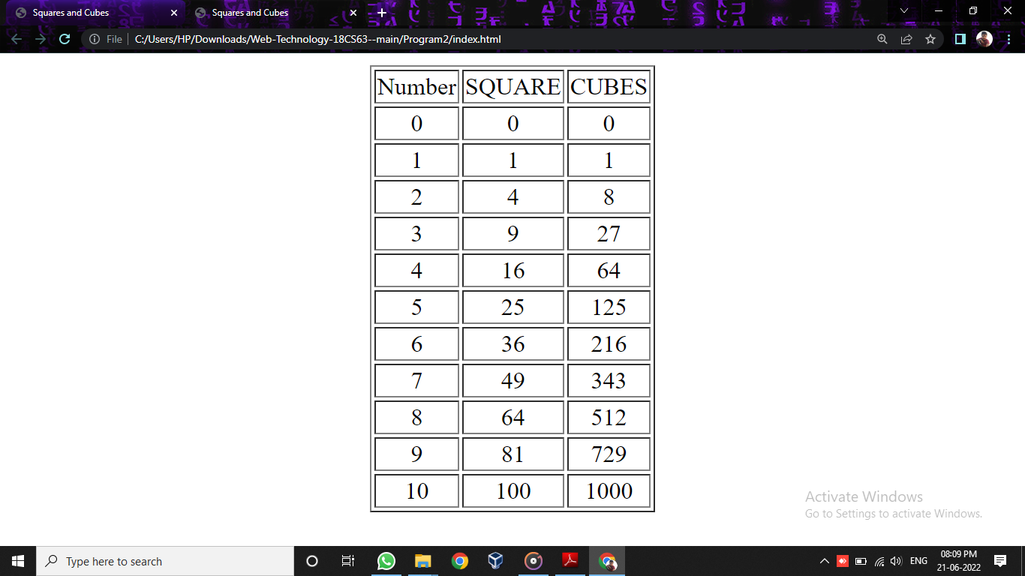

**TEST CASES:**

<!DOCTYPE html>

<html>

<head>

    <title>Squares and Cubes</title>

</head>

<body>

    <table border="1" align="center" style="background-color: skyblue;">

        <style>

            #blink{ text-align: center;

            color: blue;}

        </style>

        <tr>

            <th colspan="3">Numbers from 0 to 10with thier squares and Cubes</th>

        </tr>

        <tr align="center">

            <td>Number</td>

            <td>Squares</td>

            <td>Cubes</td>

        </tr>

        <script type="text/javascript">

            for (var i = 1; i <= 10;i++) {

                document.write("<tr align='center'><td>" + i + "</td><td>" + i * i + "</td><td>" + i * i * i + "</td></tr>")

            }

        </script>

    </table>

    <h1 id="blink" >Assignment 2 Challenge Complted</h1>

</body>

</html>

|  |  |  |
| --- | --- | --- |
| Test No. | Input Parameters | Output image |
| **1** | i=0 to 10, increment of i+=1 | **––––––––––C:\Users\HP\Pictures\Screenshots\Screenshot (35).png** |
| **2** | i=10 to 100, increment of i+=10 | **C:\Users\HP\Pictures\Screenshots\Screenshot (34).png** |
| **3** | i=100 to 1000,  increment of i+=100 | **C:\Users\HP\Pictures\Screenshots\Screenshot (33).png** |